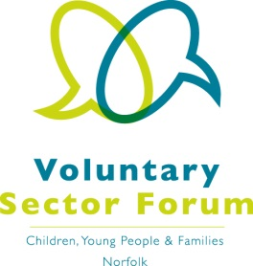
Agenda
Tuesday 5th December 2017
9am – 12.30pm
Aldiss Park, Dereham Football Club, Norwich Road, Dereham, NR20 3PX

Time | Item | Presented by | Purpose of item
9:00am | Registration and refreshments |  | Opportunity to network
9:30am | Welcome, apologies for absence and introductions. | Chair | All those attending to introduce themselves and their organisation and the services it provides
9.50am | Minutes of the last meeting and matters arising | Chair | Approve the minutes and updates on action points
 | Harmful Sexual Behaviour | Dr Romana Farooq  Specialist Clinical Psychologist & Systemic Practitioner
 | S11 feedback from the NSC | Isobel Davison
11am | Refreshment Break:  Networking and opportunity to consult with representatives
11.45am | Key issues from reps / YABS | All reps | Any key issues that Forum members need to be aware of
12.15pm | Any other business | All | Opportunity for members to update the Forum on events, issues for their groups / organisations. Please let us have your items prior to the meeting

If you wish to have a display for your organisation please contact Elaine Lincoln at Momentum.
Please confirm your attendance to forum@momentumnorfolk.org.uk

