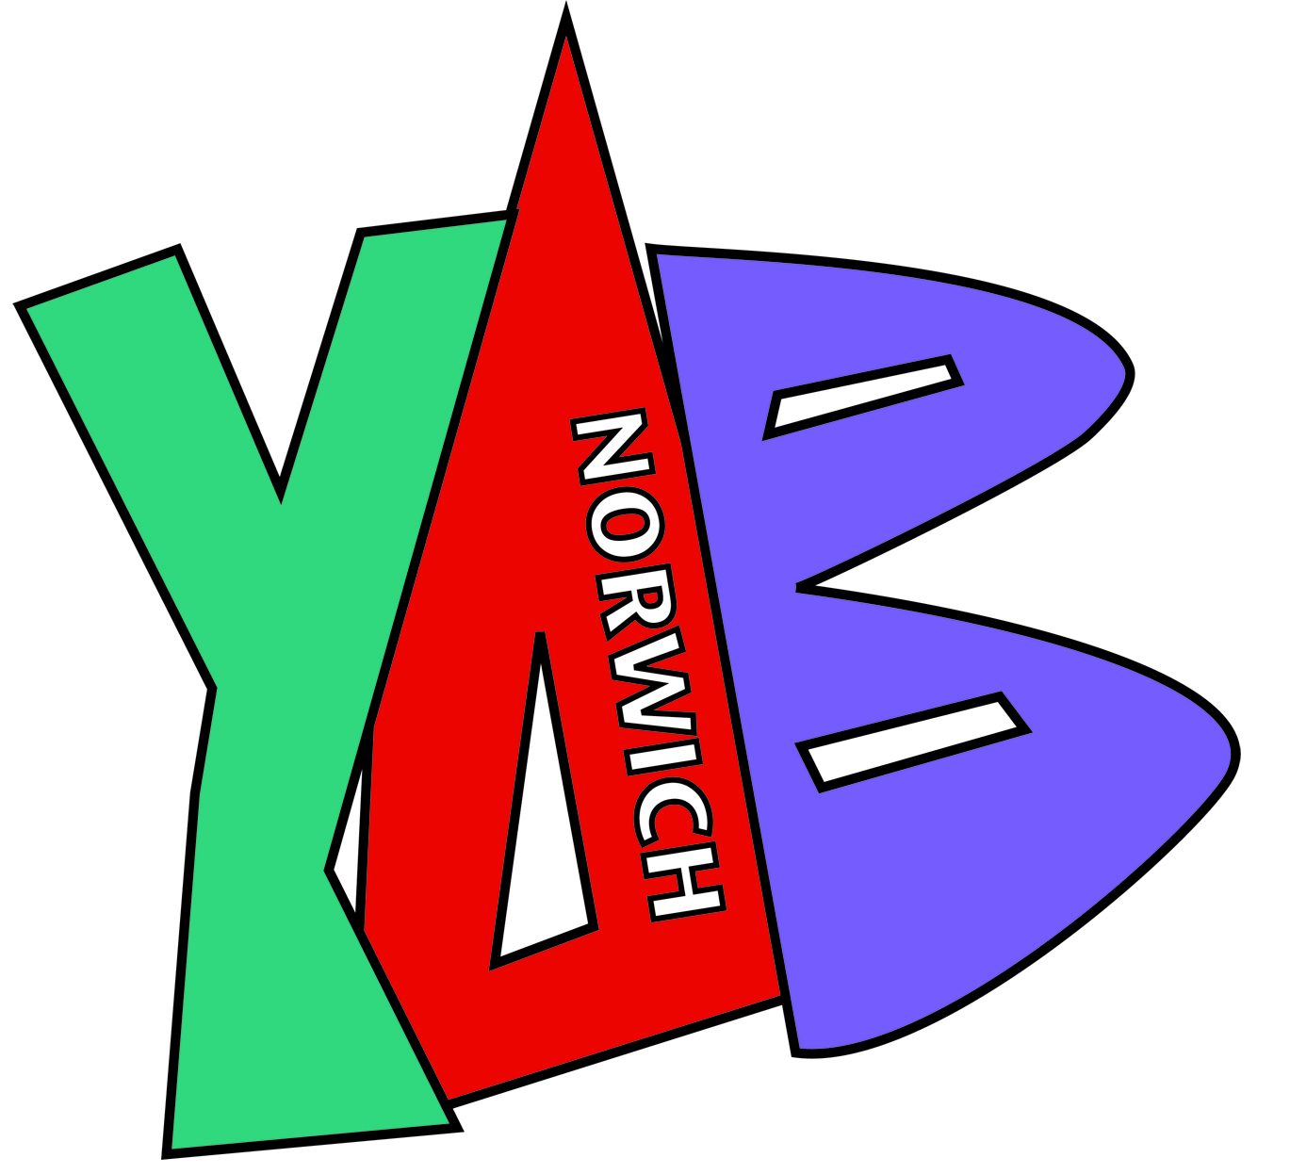

Norwich YAB 2017 Youth Consultation

The main aim of the consultation is to involve and engage young people in the YAB process. It gives young people the opportunity to share their opinions on what the key issues are and influence the YAB’s commissioning priorities. Part of the YAB’s Terms of Reference is that young people should be involved at all stages and this is a great way of reaching as many young people as possible, giving the YAB direct contact with young people and an insight into which issues are important to young people.

Consultation took place between January 2017 and March 2017, in order to ask young people what they felt the needs and issues for young people are across the city of Norwich. MAP did this through face to face conversations in and outside of different education provisions, youth clubs, groups, drop-ins, assemblies and an online survey.

What we asked young people
We asked young people to identify which of the following are issues for young people in Norwich?
- Lack of activities and youth provision
- Gaining Employment
- Accessing education or training
- ASB and Youth crime
- Bullying
- Lack of advice or guidance
- Mental health
- Physical health, diet and exercise
- Sexual health or teenage pregnancy
- Negative stereotyping of young people
- Vulnerable young people
- Racism and religious discrimination
- Youth Participation
- Other (Please state)

We also asked the young people to give us examples of why they felt these were issues, as well as their Age, Postcode and Gender.

Findings of the 2017 Youth Consultation

1675 Young People were reached during this year’s consultation in Norwich! This is 610 more young people consulted with than last year!

Demographics
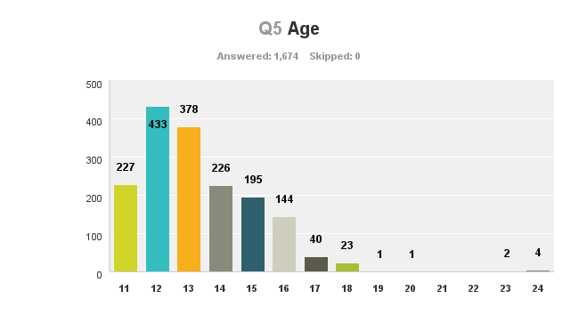
Age

As you can see, the age group we reached most were 12 year olds, consulting 433. This was closely followed by 378 13 year olds. With 227 and 226 respectively, 11 and 14 year olds were not far behind.

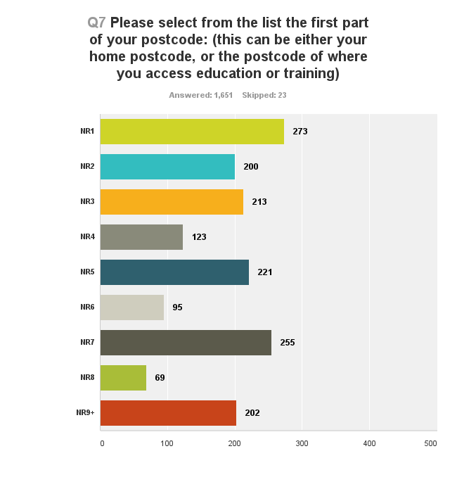
Postcode
The most popular area young people were from was NR1, with 273 young people reached. 2nd was NR7, with 255. Behind those front runners, NR5, NR3, NR3 and NR9+ had over 200 young people reached.
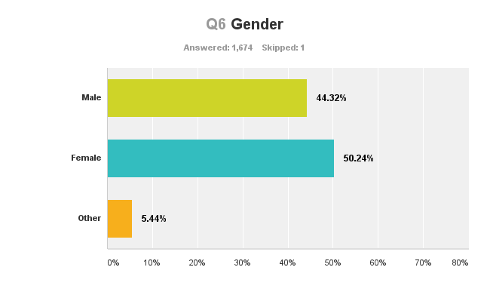
Gender
We reached more females with over 50% of the young people consulted, just over 44% male and over 5% Other.

Questions
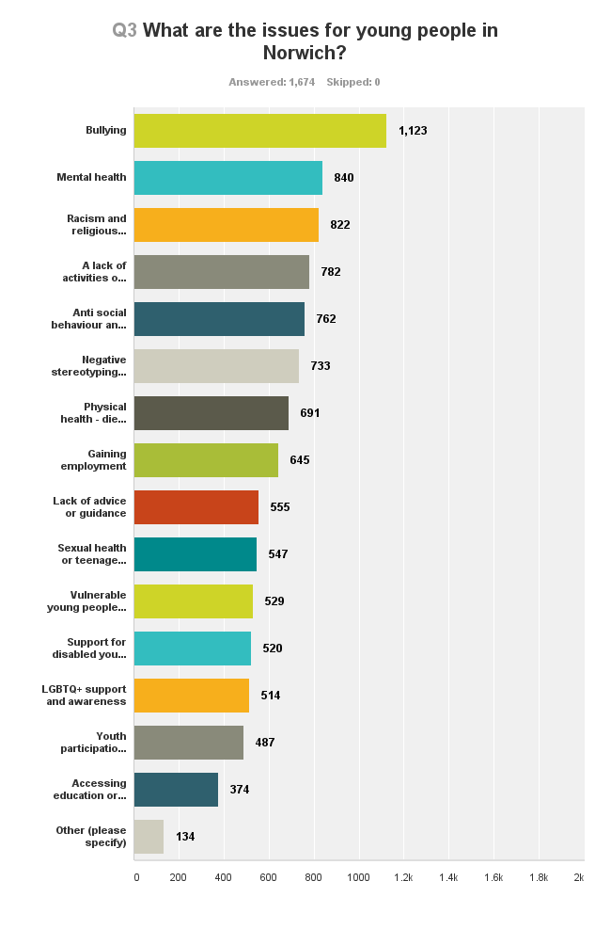

As a whole the five top issues identified are:
- Bullying (67.08%)
- Mental Health (50.18%)
- Racism and religious discrimination (49.10%)
- Lack of Activities (46.71%)
- Anti social behaviour (45.52%)
**** Closely followed by Negative stereotyping (43.79%) Physical Health, diet and exercise (41.28%) and Gaining Employment (38.53%)
.
Written examples Text size varies according to amount of times issue identified.

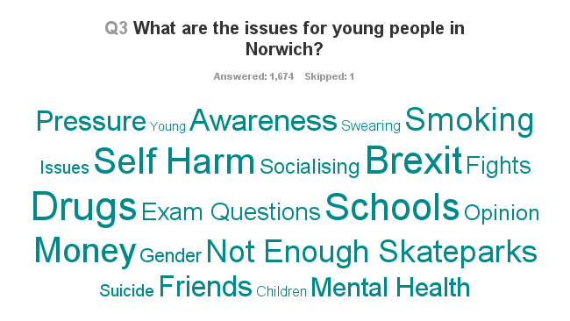

Some very important links between the issues and the examples:

1. Bullying and mental health - had many cross overs with self harm, schools, exams, pressure, suicide, gender all given as examples for each.

2. A lack of activities or things to do – Not enough Skateparks but also money (so perhaps there are things to do but not enough money to access them). Awareness, or a lack of, could also be examples of activities exist, but its dependant of where you live and the access to get there.

3. Racism and Religious Discrimination – Brexit came up a lot, regarding more incidents since the referendum and more violence, hatred to people.

4. ASB and youth crime – Drugs and ‘Norwich drug scene’ were common answers. Smoking, fights were all given as examples of this, but like with many things, is it reality or perception?

What is there and what can’t you do, written answers:
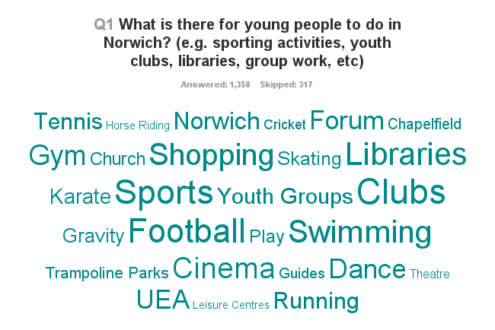

Notice the larger words, could those already in existence do more through Norwich YAB’s support or help, or does Norwich YAB acknowledge they are in existence, so should it look at the gaps? Do both? Some discussion points:

1. Libraries are very popular as something to do, so could Norwich YAB help support Libraries to reach out and offer even more? Could there be more support for groups to connect with the libraries locally?

2. Sports and mainly football were very common. UEA Sports Park, Trampoline parks and swimming were most popular sports

3. Clubs (school and youth) were also popular, young people really valued after school clubs.

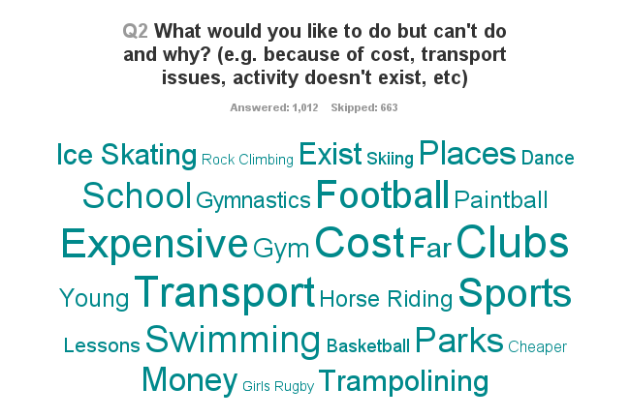

It’s important to take stock of these issues as to why people feel they can’t do an activity or access something, as this can be as important to help support as the issues themselves. Things to consider:

1. Football is a very popular ‘things to do’ but also something they would like to do but can’t. Sport for enjoyment is sometimes overshadowed by sport for competition, cost to play and transport to and form were reasons given for not be able to do it. Funding is there to set up satellite clubs for groups to help support young people access sports, can they be engage more? Do they ensure people can get to the projects?

2. ‘Cost’ and ‘expensive’ were common themes; money is a barrier for many young people consulted. There are many activities, but for many they are not reachable due to finance. Is there scope for pressure on projects which work for young people to ensure transport can be provided? Are there deals for the big sporting activities which people are unaware of?

3. Money wasn’t just about things locally – many young people wanted to explore the world, the UK, go to football games in London, travel etc but were aware finance, school and age lead to constraints. For many, the aspiration is there, just opportunities to make them happen, aren’t.

What are the main issues for 11 – 14 year olds?
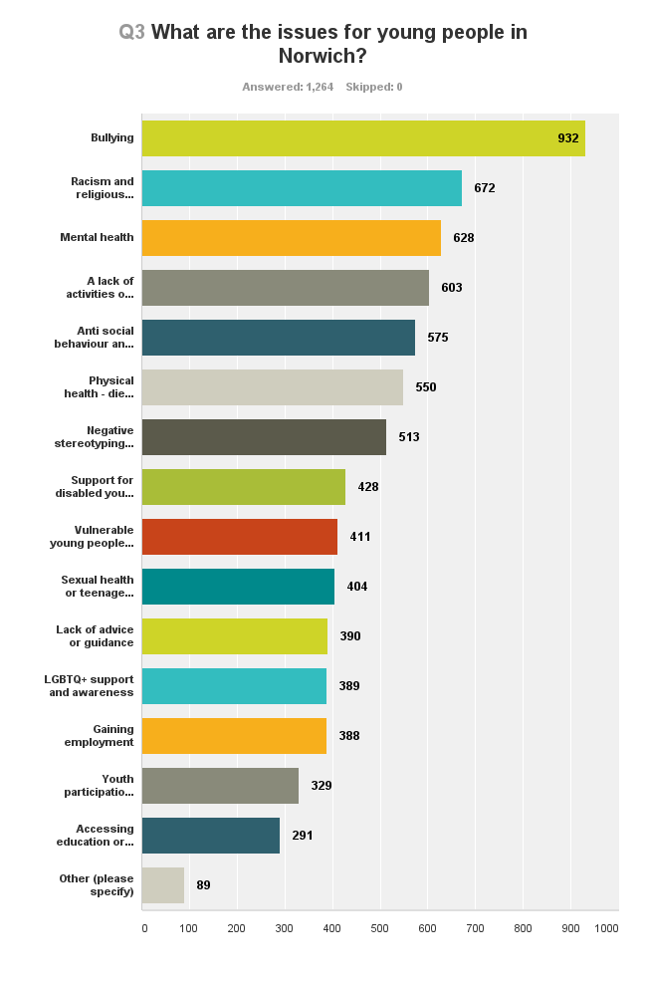

For young people aged between 11 – 14 years the top five were:

- Bullying
- Racism
- Mental Health
- Lack of Activities
- Anti social behaviour
******Closely followed by Physical Health, diet and exercise and Negative Stereotyping of young people

What are the main issues for young people 15 years to 25 years old?
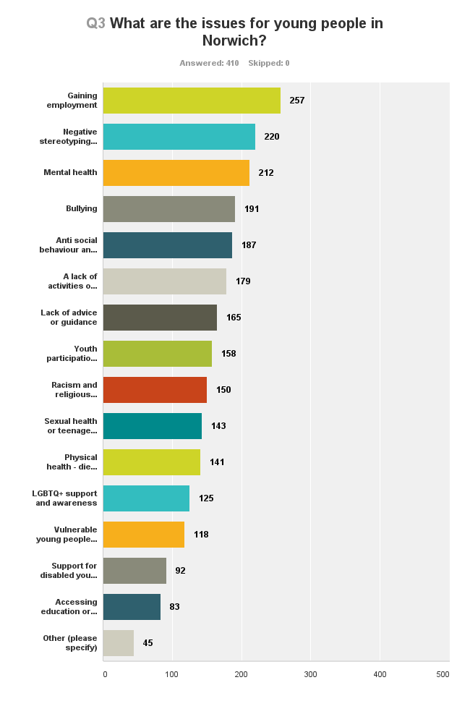

For young people aged 15-25, the top 5 were:

1. Gaining Employment
2. Negative Stereotyping
3. Mental Health
4. Bullying
5. Anti social behaviour

********Closely followed by a lack of activities and things to do and lack of advice or guidance

What are the issues for young people – Gender split

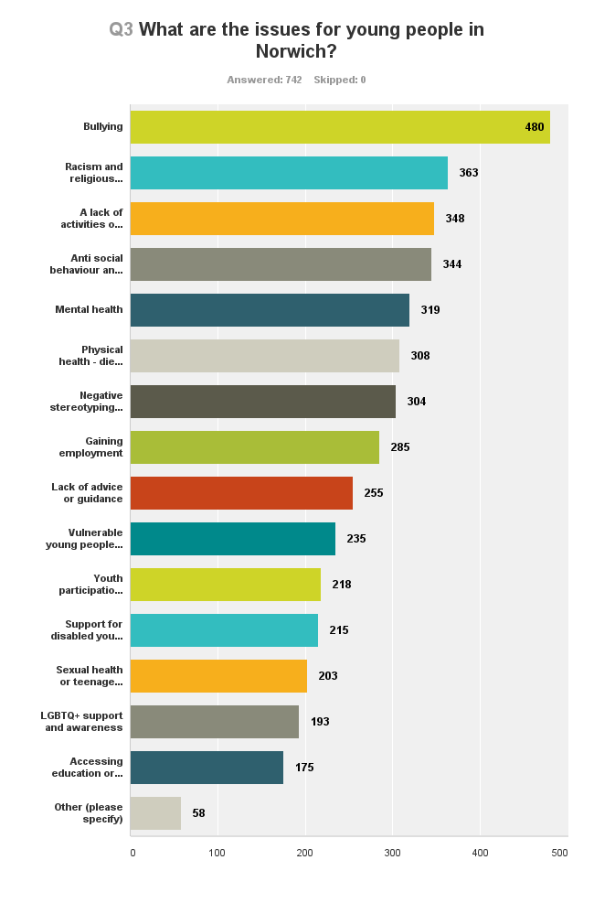
For boys aged 11-14, there wasn’t much change.
However, for boys aged 15+, gaining employment was the top issue.
Also, Accessing education and training and a lack of advice and guidance were both in the top 7 issues.

For boys, the top 5 were:

1. Bullying
2. Racism and religious discrimination
3. A lack of activities or things to do
4. Anti social behaviour and youth crime
5. Mental Health

********Closely followed by Physical health – diet and exercise and negative stereotyping of young people

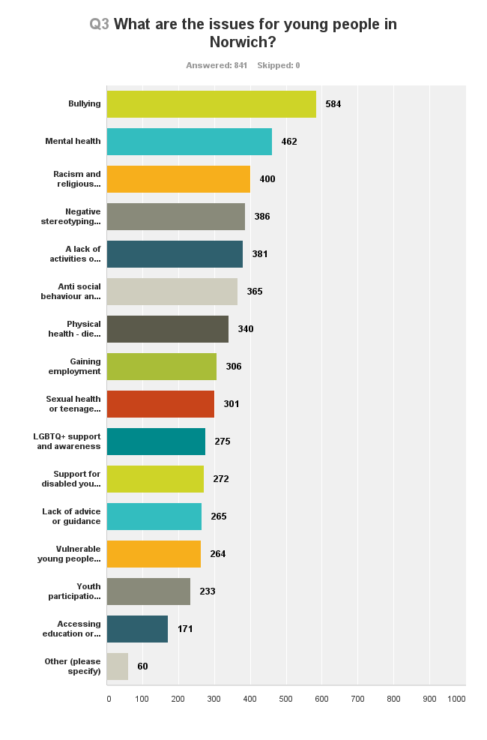
For girls aged 11-14, there wasn’t much change.
However, for girls aged 15+, gaining employment was the top issue.
The other issues didn’t change, but interestingly Accessing education and training and a lack of advice and guidance were not in the top 7 issues.

For girls, the top 5 were:

1. Bullying
2. Mental Health
3. Racism and religious discrimination
4. Negative stereotyping of young people
5. A lack of activities or things to do

********Closely followed by Anti social behaviour and youth crime and Physical health – diet and exercise

What are the issues for young people – postcode split

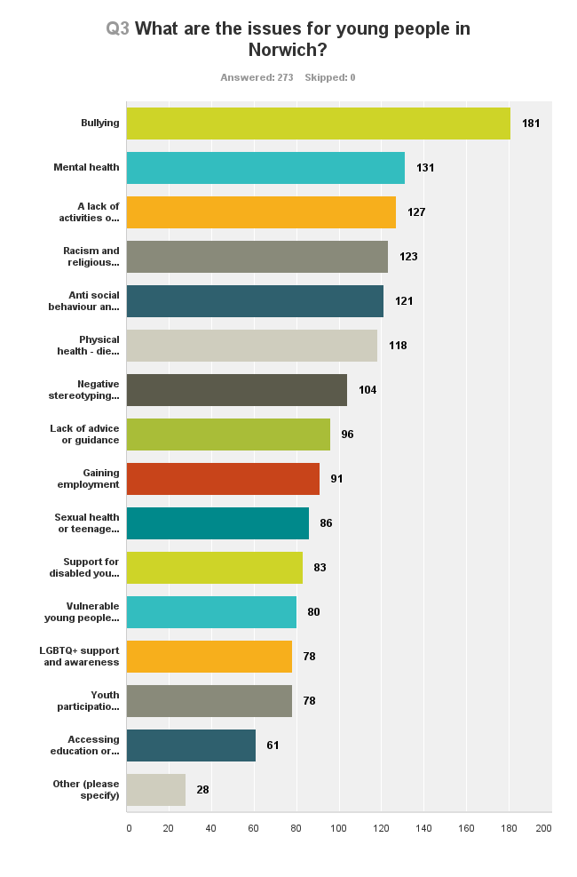
NR1
Bullying remained the top issue, with over 66% of young people from NR1 picking it as an issue. The top five doesn’t change, but racism and religious discrimination moves down and a lack of activities and things to do moves up. Physical health – diet and exercise is still high and very close to the top 5.

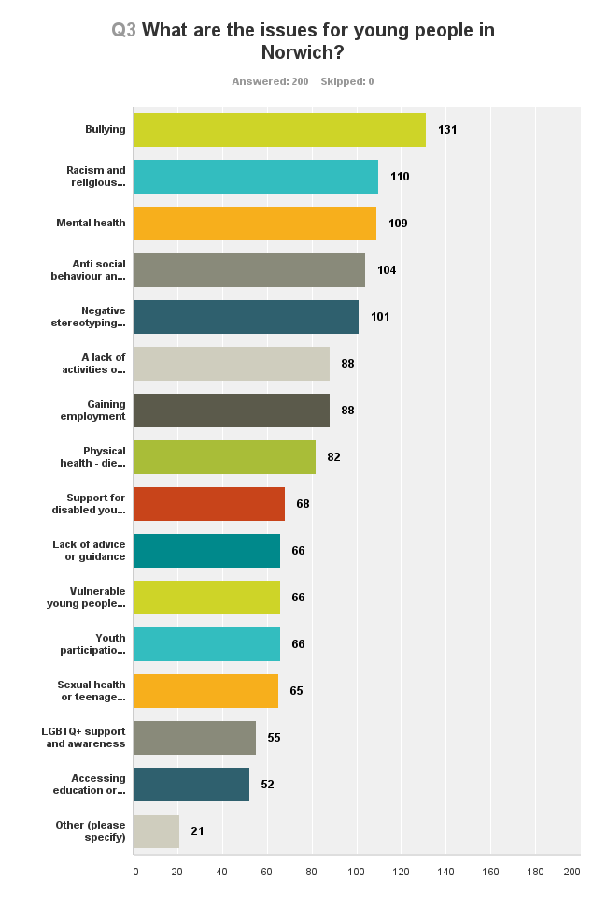
NR2
Bullying remained the top issue, with over 66% of young people from NR2 picking it as an issue. The top five changes, racism and religious discrimination moves up, mental health moves down and a lack of activities and things to do moves out of the top 5, with negative stereotyping of young people in. Gaining employment moves further up too.

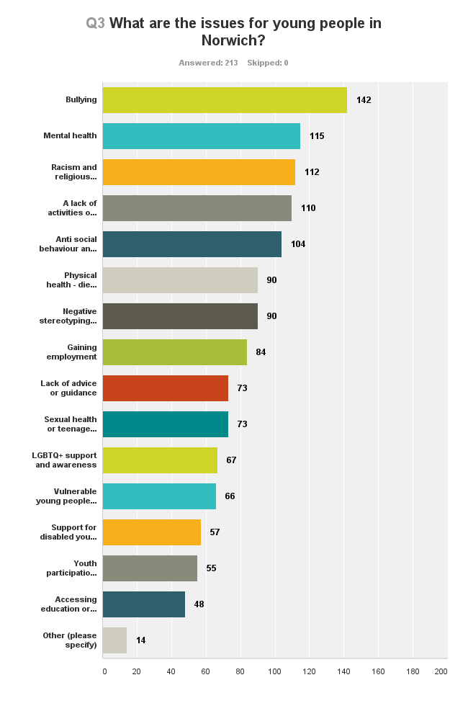
NR3
Bullying remained the top issue, with over 60% of young people from NR3 picking it as an issue. The top 5 issues remain the same and physical health – diet and exercise still close behind.

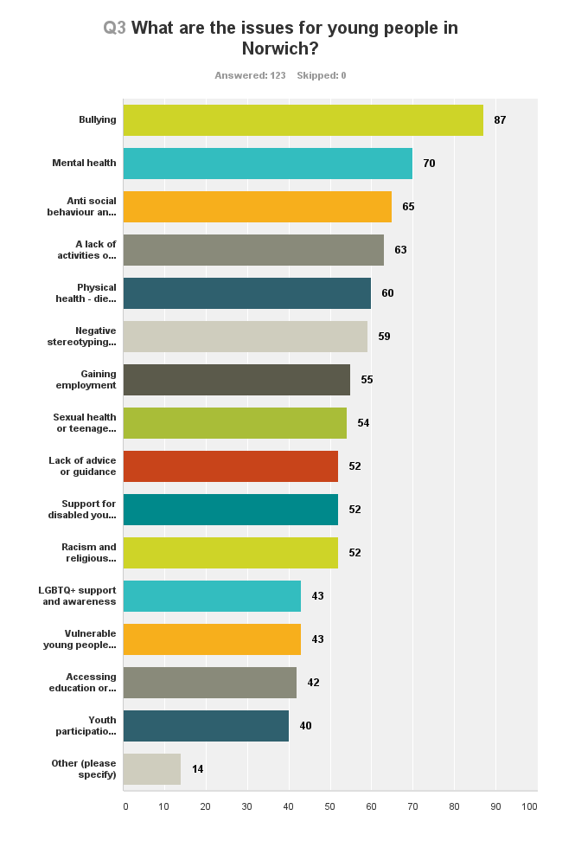
NR4
Bullying remained the top issue, with over 70% of young people from NR4 picking it as an issue. The top five changes, racism and religious discrimination moves out of the top 5, anti social behaviour and youth crime moves up to 3rd most common issue and physical health – diet and exercise moves into the top 5. Negative stereotyping of young remains a common issue and Gaining employment moves further up too.

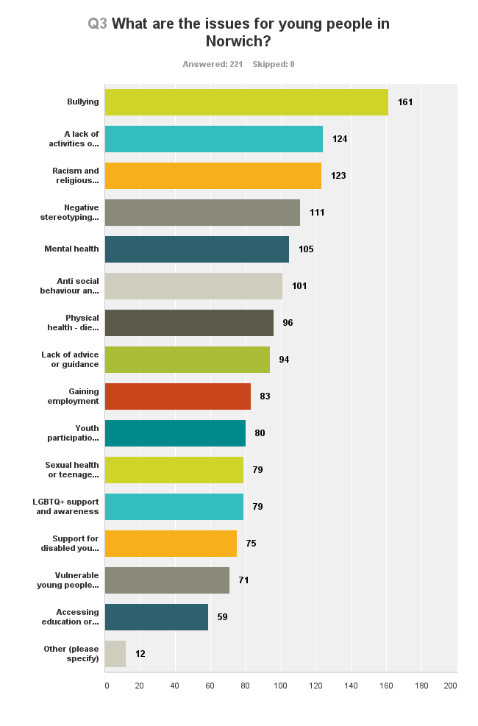
NR5
Bullying remained the top issue, with over 72% of young people from NR5 picking it as an issue. The top 5 changed, anti social behaviour and youth crime moved out of the top 5, and negative stereotyping of young people moved in. Mental health moved further down to 5th most common and a lack of activities and things to do moved up to 2nd most common. Physical health – diet and exercise still close behind and a lack of advice and guidance moved up a lot too.

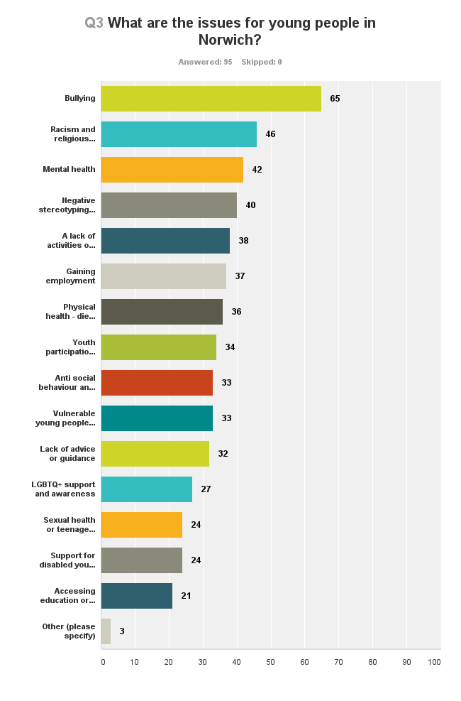
NR6
Bullying remained the top issue, with over 68% of young people from NR6 picking it as an issue. The top 5 changed, anti social behaviour and youth crime moved out of the top 5, and negative stereotyping of young people moved in. Mental health moved further down to 3rd most common and racism and religious discrimination moved up to 2nd most common. Gaining employment moved up and Physical health – diet and exercise was still close behind.

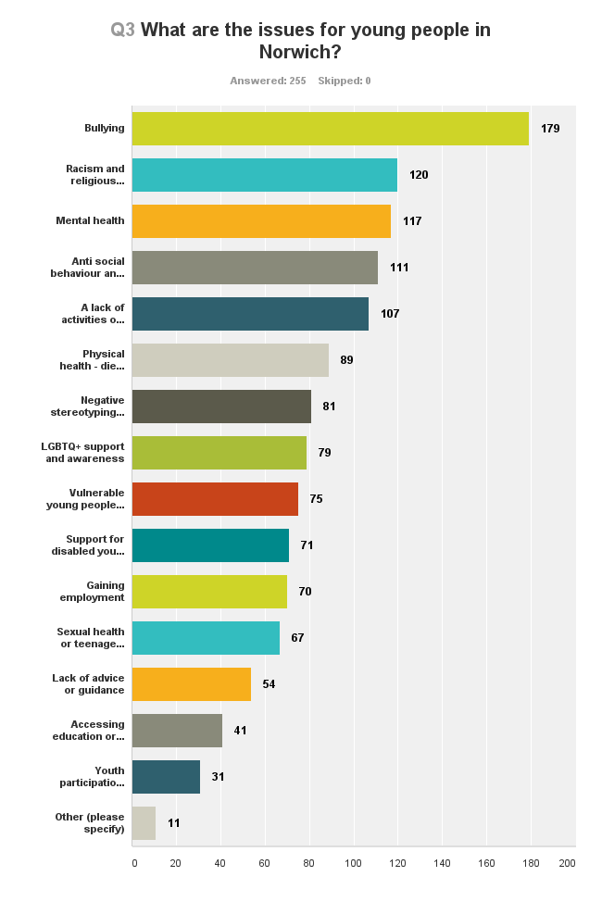
NR7
Bullying remained the top issue, with over 70% of young people from NR7 picking it as an issue. The top 5 issues remain the same however racism and religious discrimination is the 2nd most common issue and Mental health moves to 3rd most common issue. Physical health – diet and exercise still close behind.

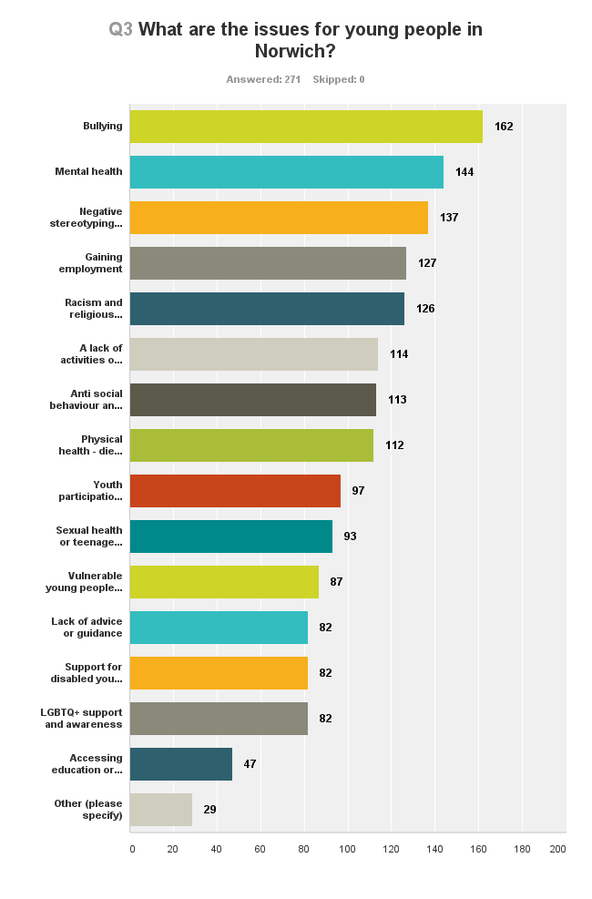
NR8 and NR9+
Bullying remained the top issue, with over 59% of young people from NR8+ picking it as an issue. The top 5 changed, anti social behaviour and youth crime and a lack of activities and things to do moved out of the top 5, and negative stereotyping of young people and gaining employment moved in. Racism and religious discrimination moved up to 5th most common.

