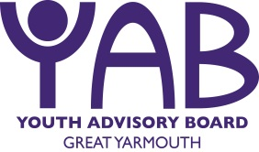

Findings from the Great Yarmouth YAB Youth Consultation
January – March 2017

Aims of the Consultation
- Involving Young People
The key aim of the consultation is to reach a diversity of young people living in the Borough of Great Yarmouth and find out from them what they consider to be the main issues affecting young people. The YAB approach emphasises that young people should be involved at all stages of the commissioning process including research and establishing YAB priorities.
- Identifying the Needs of Young People
The consultation provides an opportunity for insight into the issues that are important to young people and how the YAB can focus its resources.
- Needs Analysis
The Needs Analysis is submitted along with the Young Person’s Consultation results and includes data and statistics relating to young people and their needs. This data is collected from a range of sources including Norfolk Insight, Great Yarmouth Borough Profile, Office for National Statistics and Norfolk Health Needs Assessment. The Needs Analysis and Young person’s Consultation will inform the YAB’s commissioning priorities for 2017/18.
- Promoting the YAB to Young People and Professionals
The consultation provides an opportunity to promote and raise awareness of the YAB to young people and organisations locally.
- Mapping and local knowledge
Engaging with frontline services during the consultation is useful to highlight what provision is currently available and to identify where there are gaps.
- Youth Action Groups
The consultation provides a platform for young people who wish to take their participation a step further. As well as giving their opinions young people can join our Youth Action Groups (YAG’s). Young people who participate in YAG’s can attend YAB meetings, support the commissioning process and help assess and evaluate what the YAB does, as well as gain skills and accreditation for their own personal development moving forward.

Methods of Consultation
Quantitative and Qualitative data is collected via the following means;-
Consultation Postcard: This year the Young Commissioners re-designed the Consultation Postcard with the aim of collecting more sophisticated data. The Postcard is used as an engagement tool and discussion starter and asks young people four questions which help to draw out the main issues of concern. The Postcard is circulated locally and organisations are encouraged to support the consultation process.
Small Focus Groups: This is useful for providing space and time to work with young people to try and understand some of the issues highlighted in more depth and look at possible causes and solutions for the YAB to consider.
One to One: This is a time consuming method however is valuable in that it gives individual young people the opportunity to talk more personally about issues that they face and what they think needs to be done to address them. Young people are generally more open and honest in a one to one situation which provides significant data for the Youth Consultation.
Social Media / Online methods: This year the Young Commissioners designed a Survey Monkey which could be shared virally. Young People recognised the importance of there being opportunities for young people to respond online.

Organisations and Participants of the Consultation 2017

Educational Establishments
Flegg High School
Great Yarmouth College
East Norfolk 6th Form College
Catch 22
Bread Kitchen
Cliff Park Ormiston Academy
Lynn Grove High School
Caister High School
Statutory and Voluntary Organisations
MAP
GFS (Girls Friendly Society)
Early Help Team
Job Centre
Youth Groups and Projects
Other
We contacted the following Educational Establishments and organisations and did not receive a response, or postcards were not completed and returned.
The Matthew Project, John Grants School, YMCA, YOT

1003 Young People were reached during this year’s consultation
(That is 207 more than last year!)
Demographics
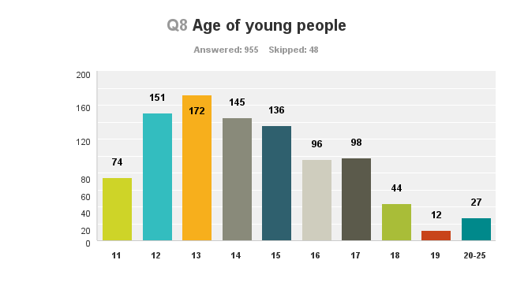
NB. 48 young people did not specify their age
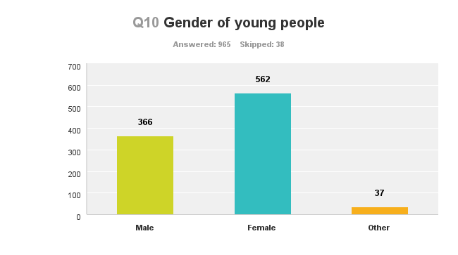
NB. 38 young people did not specify their gender

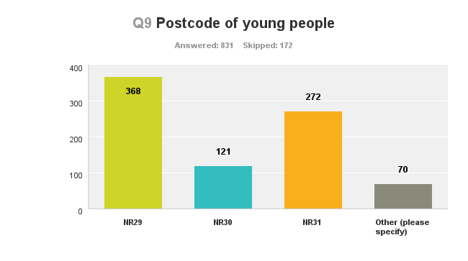
NB. 172 young people did not specify their postcode
This year we consulted with much more young people in the NR31 postcode.
Other postcodes included: NR12, NR13, NR14, NR28, NR32, NR33, NR34, NR35, (these young people were all accessing education or projects in the Borough of Great Yarmouth).

Results
Young people were asked to choose the top 5 issues that affect young people in the Borough of Great Yarmouth and rate them in order of priority (1= top issue). The scores were then awarded points, which are detailed in the table below. For each 1 (top issue) that was scored 5 points were awarded, 4 points for a score of 2, 3 for a score of 3, 2 for a score of 4, and 1 for a score of 5.
Overall results
- Drugs and Alcohol Misuse | 2135
- Bullying | 2068
- Smoking | 1867
- Anti-social behaviour/crime | 1653
- Lack of things to do | 1098
- Gaining Employment | 930
- Mental Health Awareness | 838
- Sexual Health | 573
- Being Stereotyped | 503
- Transport | 501
- Healthy Relationships | 438
- Poor emotional health and wellbeing | 455
- Health Awareness | 346
- LGBTQ+ Advice/guidance support | 311
- Lack of advice and guidance | 303
- Better advertisement of stuff for young people to do | 291
- Lack of youth participation | 247
- Accessing education or training | 230

Points to note:
- The top five issues remain unchanged from last year (Exactly the same order)
- Gaining employment and mental health awareness very close to top 5
- Health awareness has ranked higher this year
- Transport has also ranked higher this year

For the 11-15 age group:
- Drugs and Alcohol Misuse | 1586
- Bullying | 1504
- Smoking | 1503
- Anti-social behaviour/crime | 1072
- Lack of things to do | 664
- Mental Health Awareness | 508
- Gaining Employment | 467
- Being Stereotyped | 356
- Healthy Relationships | 321
- Poor emotional health and wellbeing | 287
- Sexual Health | 331
- Transport | 329
- Health Awareness | 276
- Better advertisement of stuff for young people to do | 193
- LGBTQ+ Advice/guidance support | 179
- Lack of advice and guidance | 175
- Lack of youth participation | 146
- Accessing education or training | 131

Points to note:
- The top five issues remain unchanged this year apart from Drugs & alcohol now being the biggest issue for young people of this age group (previous year was bullying)
- Gaining employment and mental health awareness very close to top 5
- Being stereotyped is more of a concern this year

For the 16 – 19 age group:
- Bullying | 446
- Drugs and Alcohol Misuse | 436
- Anti-social behaviour/crime | 416
- Gaining Employment | 386
- Lack of things to do | 319
- Mental Health Awareness | 299
- Smoking | 260
- Sexual Health | 180
- Transport | 158
- Poor emotional health and wellbeing | 145
- Being Stereotyped | 132
- LGBTQ+ Advice/guidance support | 117
- Healthy Relationships | 105
- Lack of advice and guidance | 97
- Better advertisement of stuff for young people to do | 80
- Lack of youth participation | 71
- Accessing education or training | 70
- Health Awareness | 58

Points to note:
- The top five issues remain unchanged this year apart from Bullying now being the biggest issue for young people of this age group (previous year was drug and alcohol misuse)
- Transport also seems to be a bigger issue this year for this age group

For Males:
- Drug and alcohol misuse | 771
- Bullying | 733
- Smoking | 710
- Anti social behaviour/crime | 581
- A lack of activities and things to do | 446
- Gaining employment | 426
- Mental health awareness | 246
- Transport | 234
- Sexual health | 184
- Being stereotyped | 162
- Accessing education or training | 136
- Health awareness e.g. healthy eating | 132
- Healthy Relationships e.g. family, friends and partner | 118
- Poor emotional health and wellbeing | 115
- Lack of advice or guidance | 114
- Better advertisement of stuff for young people to do | 112
- Lack of youth participation | 102
- LGBTQ+ advice/guidance support | 94
- Other responses | 61

For females
- Drug and alcohol misuse | 1216
- Bullying | 1182
- Anti social behaviour/crime | 958
- Smoking | 707
- A lack of activities and things to do | 572
- Mental Health awareness | 562
- Gaining employment | 459
- Poor emotional health and wellbeing | 309
- Sexual Health | 308
- Being stereotyped | 297
- Healthy Relationships e.g. family, friends and partner | 286
- Transport (cost or lack of) | 246
- Health awareness e.g. healthy eating | 198
- LGBTQ+ advice/guidance support | 185
- Lack of advice or guidance | 178
- Better advertisement of stuff for young people to do | 162
- Lack of youth participation | 119
- Accessing education or training | 102
- Other responses | 15

Things to note: top five are the same, but slightly change in order. Most health categories scored higher than males. Accessing education or trainings cored lower in females than males.

- Bullying | 619
- Drugs and Alcohol Misuse | 474
- Smoking | 454
- Anti-Social Behaviour and Crime | 416
- Lack of Things to Do | 311
- Mental Health Awareness | 297
- Gaining Employment | 279
- Sexual Health | 197
- Healthy Relationships | 141
- Being Stereotyped | 140
- Poor Emotional Health and Wellbeing | 137
- Transport | 107
- LGBTQ+ Advice/guidance support | 99
- Lack of Advice and Guidance | 79
- Health Awareness | 75
- Lack of Youth Participation | 72
- Better Advertisement of stuff for young people to do | 70
- Accessing Education or Training | 63
For NR31:

Points to note:
- Top five issues remain unchanged but the order has changed. Bullying is now the top issue whereas last year anti-social behaviour was the biggest issue.
For NR30:
- Anti-Social Behaviour and Crime | 275
- Bullying | 219
- Drugs and Alcohol Misuse | 217
- Gaining Employment | 210
- Lack of Things to Do | 184
- Smoking | 132
- Mental Health Awareness | 124
- Poor Emotional Health and Wellbeing | 67
- Being Stereotyped | 63
- Accessing Education or Training | 56
- Sexual Health | 55
- Transport | 55
- Better Advertisement of stuff for young people to do | 49
- Lack of Youth Participation | 45
- Healthy Relationships | 43
- LGBTQ+ Advice/guidance Support | 42
- Lack of Advice and Guidance | 32
- Health Awareness | 27

Points to note:
- Top five issues have slightly changed with NR30 worried more about gaining employment than the two other areas.

For NR29:
- Drugs and Alcohol Misuse | 937
- Smoking | 839
- Bullying | 700
- Anti-Social Behaviour/Crime | 497
- Lack of Things To Do | 325
- Gaining Employment | 313
- Mental Health Awareness | 286
- Transport | 202
- Being Stereotyped | 191
- Sexual Health | 182
- Health Awareness | 162
- Healthy Relationships | 160
- Poor Emotional Health and Wellbeing | 152
- Lack of Advice and Guidance | 133
- Better Advertisement of Stuff for young people to do | 123
- LGBTQ+ | 119
- Lack of Youth Participation | 75
- Accessing Education or Training | 57

Points to note:
- Top five issues remain unchanged but smoking and bullying have switched places.
- Healthy relationships has ranked higher this year

What is there for young people to do in the Borough of Great Yarmouth?
Young people were asked ‘What is there for young people to do in the Borough of Great Yarmouth?’ to gauge what young people are accessing, these were the most common answers:
Sporting activities
Sports came up a lot on the postcards including the following:
Pool, Football, Gym, Swimming, Basketball, Rugby, Skateboarding, Tennis, Horseriding, Karate, Gymnastics and Dance
Attractions
Amusements/Arcades, Beach/Seafront, Parks, Marina Centre, Jump Warehouse, Cinema, Retroskate, Gym, Library, Sealife centre, Crazy Golf and Quasar
Voluntary Organisations/ Clubs
Cadets, Great Yarmouth Gateway Club, MAP, GFS, Beavers/Scouts and The Bread Kitchen

This is a word cloud of some of the words that were used the most:
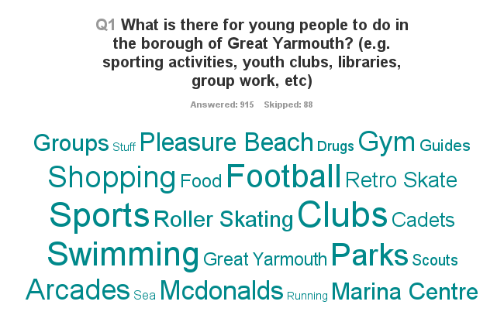
Many other general activities were listed like arts and crafts, drama groups, eating and shopping, theatre, circus. .
Many young people frequently noted McDonalds as something to do/a place to hang out. Also other fast food places like KFC, Burger King and Subway.
Youth clubs were mentioned on many of the consultation cards but not many youth clubs were specified and the Library. Many young people stated the park as something to do but said that it was dangerous or unsafe.
It was noted many times that young peoples stuff is not advertised enough. Drugs, alcohol and getting into trouble were also mentioned several times.
What would young people like to do but can’t do and why?
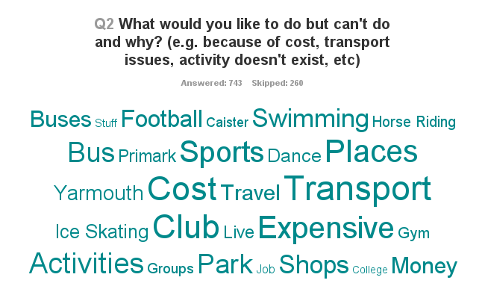
One of the biggest issues for young people is the cost of activities and transport and the availability of transport. These are big barriers for young people in Great Yarmouth.
Young people feel that Great Yarmouth is not a safe place and would like somewhere safe and warm that they can chill out. They often get kicked out of McDonalds, or are intimidated on the streets by others.
“Walk around yarmouth and not feel intimidated by drunk people”
“Have more safe areas to meet up with friends”
Many young people said that they would like a decent skate park. Many would like ice skating facilities, others would like and art club and many wanted to travel but would not be able to.

