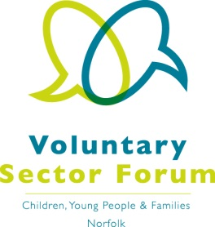
Agenda
4 December 2018
9.00am – 12.30pm
Aldiss Park, Dereham Football Club, Norwich Road, Dereham, NR20 3PX

Time | Item | Presented by | Purpose of item
9.00am | Registration and refreshments |  | Opportunity to network
9.30am | Welcome, apologies for absence and introductions | Chair | All those attending to introduce themselves and their organisation and the services it provides
9.45am | Minutes of the last meeting and matters arising | Chair | Approve the minutes and updates on action points
9.50am | Information | Sue Lowe,  The Big Lottery Fund | Update on funding and sector news
10.20am | Information | Michelle Walker, Co-production and Service User Lead, Cambridgeshire Community Services NHS Trust | Launch of the new “Just One Norfolk” website
10.50am – 11.20am | Refreshment Break
11.20am | Changes at Norfolk Community Foundation | Claire Cullens,  CEO of Norfolk Community Foundation | Introduction to the new CEO of Norfolk Community Foundation and her vision for the future
11.50am | Organisation news and discussion points | Chair | Opportunity for those present to update the Forum on issues for their organisations that may require representation
12 noon | Issues for representatives | Chair | Commissioning the representatives on the key issues facing our sector
12.10pm | AOB:  Looked After Children and Care Leavers  Next meeting agenda | Chair  Mike Pepperell – Prospects | Identify the issues we want to raise with future Speakers
Dates of future meetings: |  | - Tuesday 5th March 2019  - Wednesday 5th June 2019  - Tuesday 10th September 2019  - Wednesday 4th December 2019

If you wish to have a display for your organisation please contact Elaine Lincoln at Momentum.
Please confirm your attendance to forum@momentumnorfolk.org.uk

