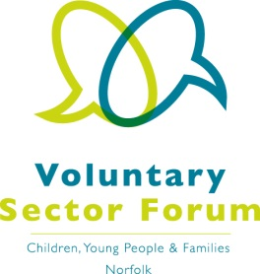
Agenda
5 June 2019
9am – 12.30pm
Aldiss Park, Dereham Football Club, Norwich Road, Dereham, NR20 3PX

Time | Item | Presented by | Purpose of item
9.00am | Registration and refreshments |  | Opportunity to network
9.30am | Welcome, apologies for absence and introductions | Vice Chair | All those attending to introduce themselves and their organisation and the services it provides
9.45am | Minutes of the last meeting and matters arising | Chair | Approve the minutes and updates on action points
9.50am – 10.15am | Government youth focussed work, policy and priorities | Suzanne Lowe | Update
10.15am – 10.45am | Feedback on the Section 11 reporting process | Natasha Rennolds – NSCB Lay member | Update
10.45am- 11am | Update on CYPMH transformation work | Clare Morris – Rethink
11am – 11.30am | Refreshment Break
11.50am – 12 noon | Queens Award for Voluntary Service | Peter Wilson, on behalf of HM Lord-Lieutenant of Norfolk | Information
12 noon | Organisation news and discussion points | Chair | Opportunity for those present to update the Forum on issues that may require representation
12.10pm | Issues for Representatives | Chair | Commissioning the representatives on the key issues facing our sector
12.25pm | AOB / future agenda items | Chair | Please let us have your items beforehand. A chance to identify issues for future meetings
Dates of future meetings: |  | - Tuesday 10th September 2019  - Wednesday 4th December 2019

If you wish to have a display for your organisation please contact Elaine Lincoln at Momentum.
Please confirm your attendance to forum@momentumnorfolk.org.uk

