Play Area
Inspection Course

Wednesday 28 November 2018
10.00 am - 1.30 pm

WHAT  Professional training for play equipment inspection  WHEN  Wednesday 28 November 2018  10.00 am – 1.30 pm  WHERE  Signpost House, Dereham  NR20 3TL  COST  £40 CAN members  £60 non-members  Cheques payable to Community Action Norfolk  Bank Transfer to Community Action Norfolk, Unity Trust Bank, Sort Code 60-83-01 Account No 20359346  Please quote our ref: CANPT | The course is aimed at helping those responsible for managing play spaces learn how to effectively inspect their play equipment on a regular basis.  The course will be led by Rik Martin RPII, registered Operational Inspector of Children’s Playgrounds.  The session will include a classroom element as well as an inspection of a nearby play area. Attendees are recommended to dress appropriately for climbing on play equipment and for weather conditions.  Please arrive at Community Action Norfolk’s office at  9.45 am for a 10.00 am start.  Please return this booking form (complete below) with payment to Community Action Norfolk, Signpost House, Ambassador Way, Greens Road, Dereham, NR20 3TL  For more information call 01362 698216 or e-mail office@communityactionnorfolk.org.uk

Name…………………………………………………………………………………
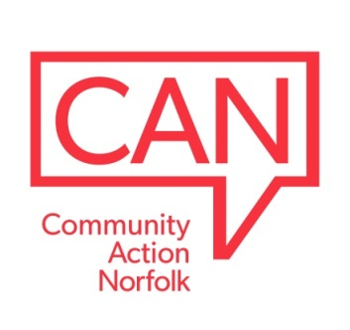
Organisation………………………………………………………………………..
CAN Members? Yes/No (Please delete as appropriate)
Address………………………………………………………………………………
………………………………………………………………………………………...
Tel……………………………………………………………………………………..
Email:………………………………………………………………………………… www.communityactionnorfolk.org.uk

