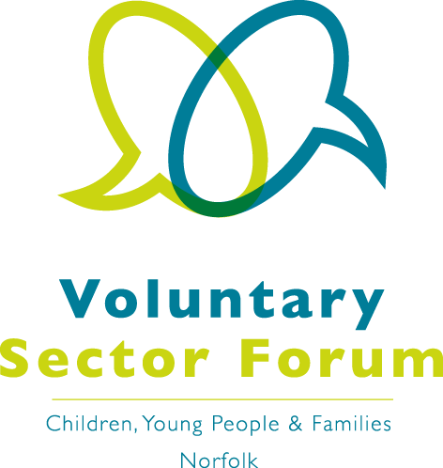

Voluntary Sector Forum
(Children, Young People and Families)
Registration

Your name:

Your role in your organisation:
Organisation name:

Organisation address including postcode:

Your email address:
This will be visible to all Forum members when sending meeting invites.

Please indicate the district/s that your organisation provides a service in:

District: | ✓ | District: | ✓
County-wide |  | King’s Lynn & West Norfolk
Breckland |  | North Norfolk
Broadland |  | Norwich
Great Yarmouth |  | South Norfolk

Signature: | Date:

Please return your completed form to forum@momentumnorfolk.org.uk

Please note that each organisation has only one vote in elections,
this would usually be the most senior representative of the organisation

