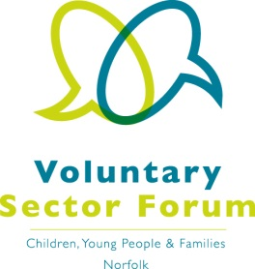
Agenda
14 July 2020; 10.00am – 12.00 noon
Microsoft Teams meeting

Time | Item | Presented by | Purpose of item
10.00am | Welcome and introductions | Chair | All those attending to introduce themselves and their organisation
10.15am | Minutes of the last meeting and matters arising | Vice Chair | Approve the minutes and update on action points
10.20am | Update on SEND Inspection | Michael Bateman, Programme Director for SEND and Alternative Provision, Children’s Services
10.35am | Break
10.45am | Update; successes and challenges within the sector | Vice Chair
11.30am | Funding update | Jenny Bevan, Head of Programmes, Norfolk Community Foundation | Update on funding and future opportunities
11.50am | AOB and future agenda items | Chair | Update on the Assembly.  Identify future agenda items.

Dates of future meetings: October 2020 – date to be confirmed, Wednesday 2 December 2020

Please note that the scheduled meeting on 16 September has been postponed until October and will be an online meeting.

