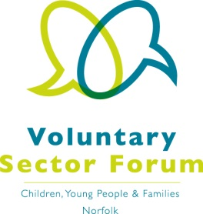
Agenda
14 October 2020; 2.00 – 4.00pm
Microsoft Teams meeting

The meeting will be recorded for minute taking purposes only.

Time | Item | Presented by | Purpose of item
2.00pm | Welcome and introductions | Chair | All those attending to introduce themselves via chat facility on TEAMs
2.15pm | Minutes of the last meeting and matters arising | Vice Chair | Approve the minutes and update on action points
2.25pm | Norfolk Coalition for Supporting Wellbeing (CYP) | Cindee Crehan, Sir Norman Lamb Mental Health & Wellbeing Fund Coordinator, Norfolk Community Foundation | Presentation on the plans for the Sir Norman Lamb Fund for Mental Health and Wellbeing
2.40pm | Feedback on Engagement with the VSCE Sector | Nicki Bramford, Service Director for Children, Families and Young People, Norfolk and Suffolk Foundation Trust | Feedback from the session held by Rob Mack with Forum members in March 2020.
3.00pm | Break
3.10pm | Sector representation | Chair and Vice Chair | Discussion of sector representation on boards and new Momentum Manager role.
3.30pm | Update on Assembly | Lucy Hogg, Head of Voluntary Sector Infrastructure, Voluntary Norfolk | Update presentation on VCSE Health & Social Care Assembly
3.45pm | AOB and future agenda items | Chair | S11 Report; Safeguarding during the pandemic. Learning points in the event of a future lockdown.  SEND Inspection Report; sector views.  2nd December meeting; online TBC  Identify future agenda items.

Dates of future meetings: Wednesday 2 December 2020 – details TBC

