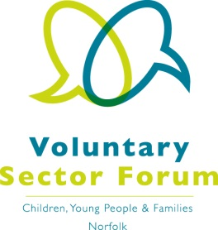
Agenda
2 December 2020; 10.00am – 12.00 noon
Microsoft Teams meeting

Time | Item | Presented by | Purpose of item
10.00am | Welcome and introductions | Chair | All those attending to introduce themselves via chat facility on Microsoft Teams
10.10am | Minutes of the last meeting and matters arising | Vice Chair | Approve the minutes and update on action points
10.20am  10.50am | NCC Targeted Youth Support Service  Vulnerable Adolescent Group Partnership Forum | Lauren Downes, Head of Youth  Aimee Gedge, Momentum Manager | Update and Q&A
11.00am | Break
11.10am | Sector representation  Priorities for the Forum: What are we trying to change and influence? | Chair and Vice Chair | Update on sector representation on boards
11:40am | 2021 Focus |  | Ideas for 2021 meeting themes
11.50am | AOB / and future agenda items, if not covered above | Chair | Identify future agenda items

Dates of future meetings:
- Tuesday 2 March – Microsoft teams
- Wednesday 2 June
- Tuesday 14 September
- Tuesday 7 December

