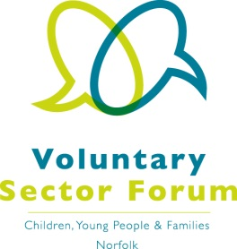
Agenda
2 March 2021; 10.00am – 12.00 noon
Microsoft Teams meeting

Time | Item | Presented by | Purpose of item
10.00am | Welcome and introductions | Chair | All those attending to introduce themselves via chat facility on Microsoft Teams
10.05am | S11 feedback process | Dr Mark Osborn,  Safeguarding Intelligence & Performance Co-ordinator, NCC Children's Services | Update on the changes for 2021
10.25am | Active Norfolk’s 5 year Strategy and Funding | Stephen Hulme, Active Norfolk | Update
10.50am | Break
11.00am | Minutes of the last meeting and matters arising | Chair | Approve the minutes and update on action points
11.10am | Key Messages | Chair | Discussion and feedback on the questions detailed below.
11.40am | Representation | Chair and Aimee Gedge, Momentum Interim Manager | Update
11.50am | AOB | Chair | Identify future agenda items

Key messages; Questions to be considered during the meeting and feedback shared
- What do you want most from commissioners?
- What is the value in the VCSE and statutory sectors working closely together? What new opportunities might be created by a stronger working relationship?
- What are the short-term challenges facing the sector (e.g. from covid)? What are the longer-term challenges post-covid?

Dates of future meetings:
- Wednesday 2 June 2021, 10am – 12 noon; Microsoft Teams
- Tuesday 14 September 2021, 10am – 12 noon; Microsoft Teams
- Tuesday 7 December 2021, 10am – 12 noon; Microsoft Teams

